**Department of Information Engineering Technology**

**Superior University Lahore**

**Assignment-2**

**SUBJECT: Web Engineering COURSE CODE: TIT601450**

**TIME ALLOWED: 3 days MAX. MARKS: 20**

**TERM: Fall 2023 DATED: 18-12-2023**

**STUDENT ID. Biet-f21-049 NAME: Zunaisha Noor**

___________________________________________________________________

|  |  |  |  |  |
| --- | --- | --- | --- | --- |
| **Sr. No** | **CLO’S** | **Domain** | **Taxonomy Level** | **PLO** |
| **1** | **Design** web pages using HTML, CSS, and interactive web elements by using JavaScript. | Cognitive | C-5 | PLO3 |
| **2** | **Analyze** the React framework to streamline web development. | Cognitive | C-4 | PLO3 |

**React.js Assignment**

**Introduction:**

Welcome to the React.js assignment! This assignment is designed to assess your understanding of React.js, a popular JavaScript library for building user interfaces. Please follow the instructions carefully and submit your solution by the specified deadline.

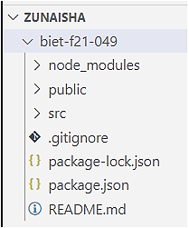**Task 1:** Setting up the Project Create a new React.js project using Create React App or any other preferred method. Ensure that your project is set up correctly and runs without errors.

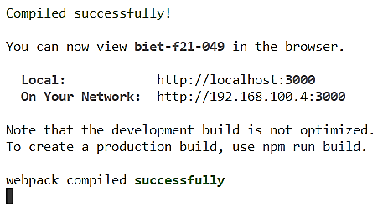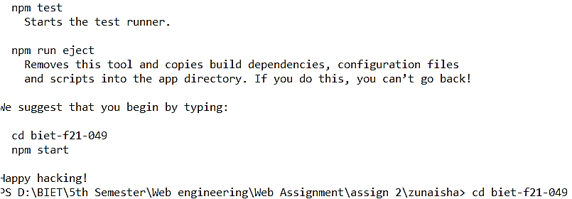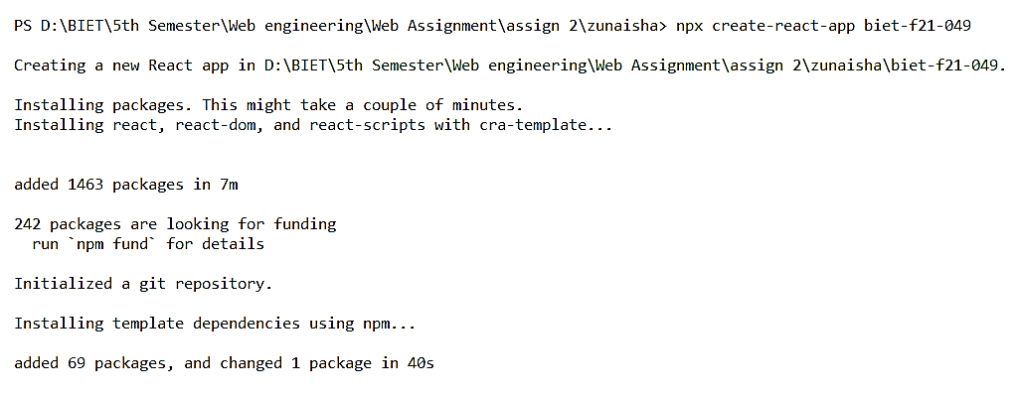

**Task 2:** Component Creation Create the following React components:

1. Header: Create a header component that displays the title of your application. The title should be customizable and passed as a prop to the Header component.

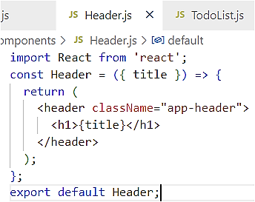

1. TodoList: Create a todo list component that displays a list of tasks. Each task should be represented as a separate component (TodoItem). The TodoList component should receive an array of tasks as a prop and render the list dynamically.

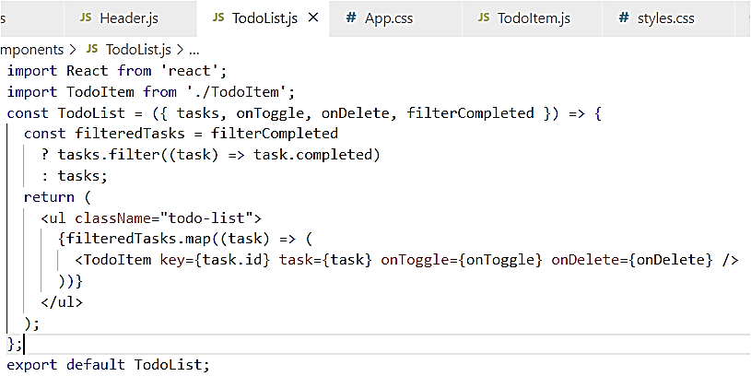

1. TodoItem: Create a todo item component that represents an individual task. Each TodoItem should display the task content and have a checkbox to mark the task as completed. Implement a function to toggle the completion status when the checkbox is clicked.

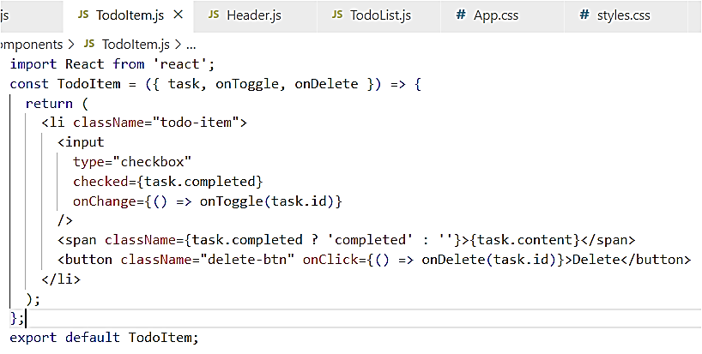

**Task 3:** State Management Implement state management for the TodoList and TodoItem components. Use state to keep track of the completion status of each task and update it dynamically when the user interacts with the checkboxes.

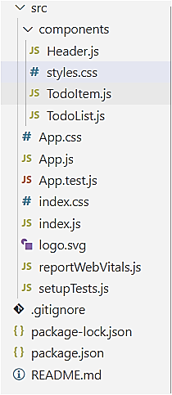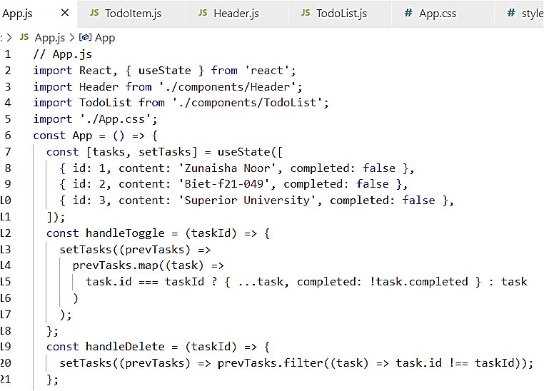 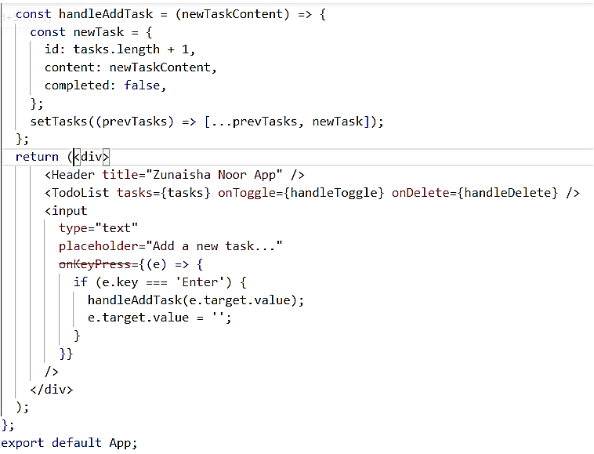

**Task 4:** Styling Apply styles to your components to make the user interface visually appealing. You can use CSS, styled-components, or any other styling approach of your choice.

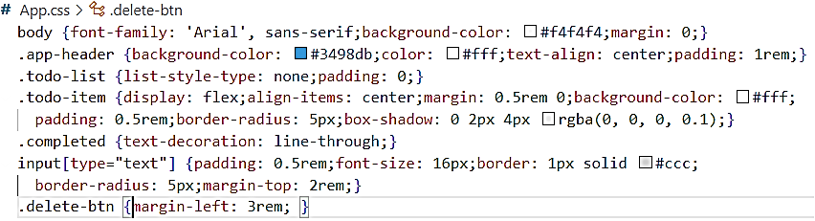

**Task 5:** Bonus (Optional) Implement additional features to enhance your application, such as:

* Task deletion
* 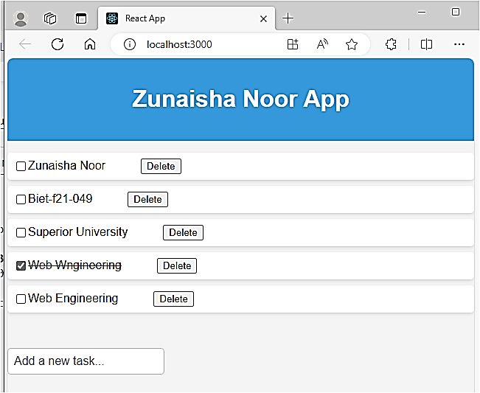Filtering tasks based on completion status
* Adding new tasks dynamically

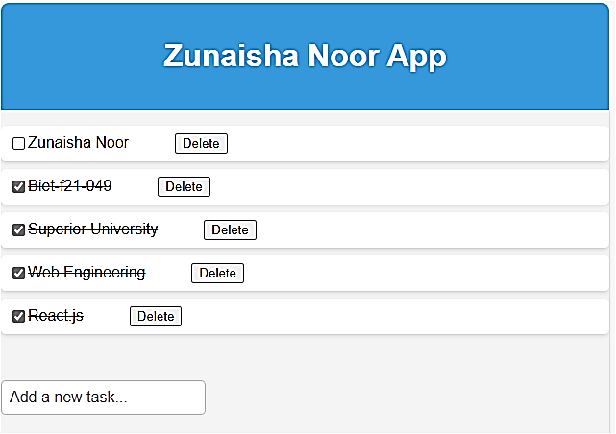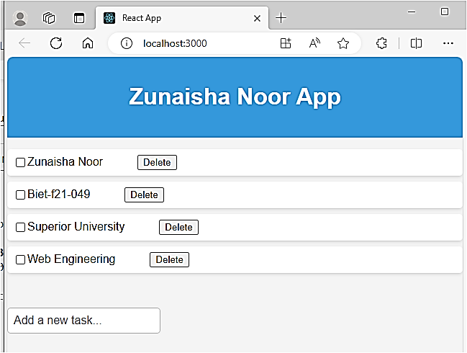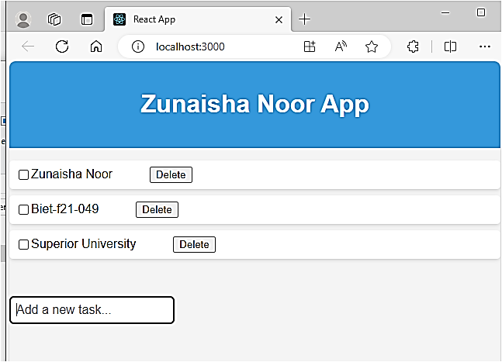

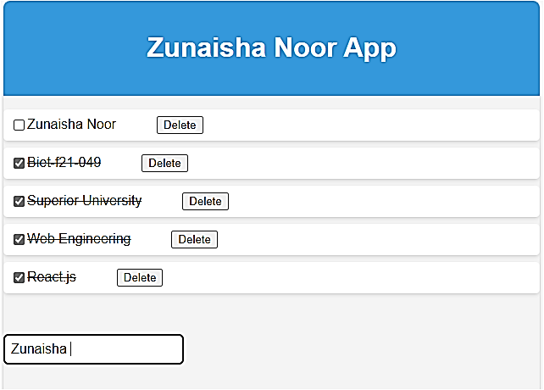

**README file:**

